**APPENDIX A**

**SNAPSHOTS**

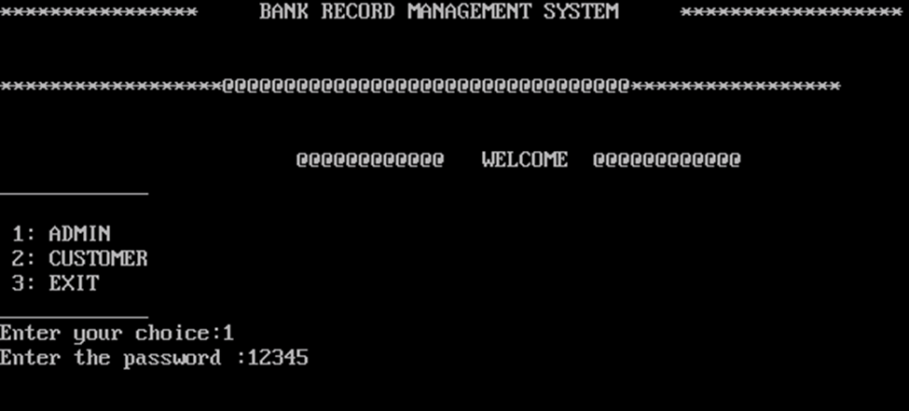

Snapshot 1: Login Page of Bank Record System.

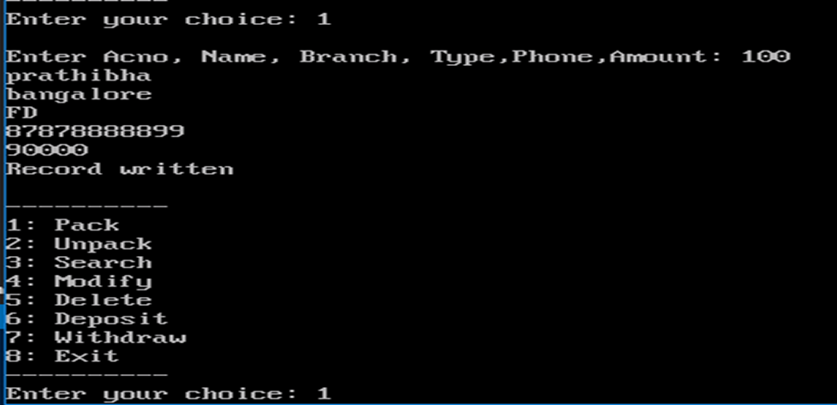

Snapshot 2: Creating and Inserting account details of Account Holder.

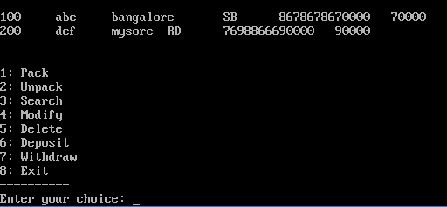

Snapshot 3: Displaying details of the Record if exists.



Snapshot 4: File content before deletion of record (100).

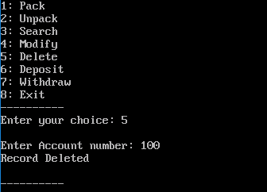

Snapshot 5: Deleting the Record.

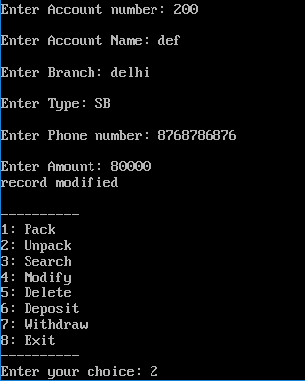

Snapshot 6: Modifying the content of Record.

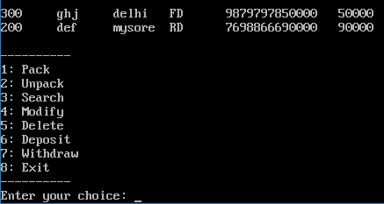

Snapshot 7: Static Reclamation of Buffer Space.



Snapshot 8: File content after static reclamation of buffer space.